A000-Asia-C China-Shang-Guang-Alligator with Muntjak Deer Horns- Shilou County, Lüliang, Shanxi-Bronze-1600-1046 BCE

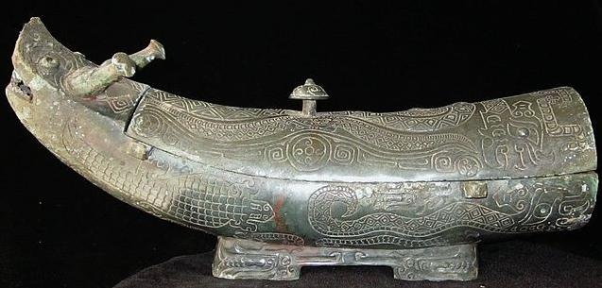

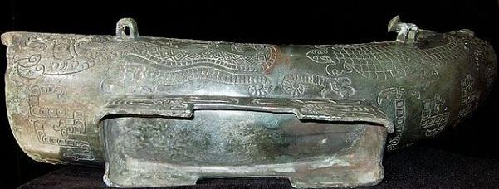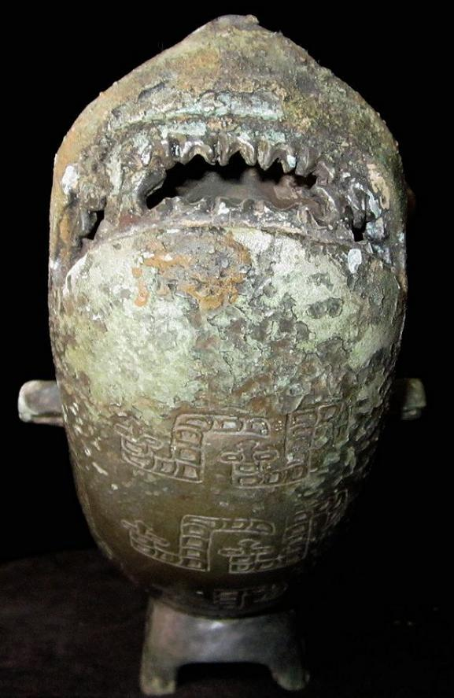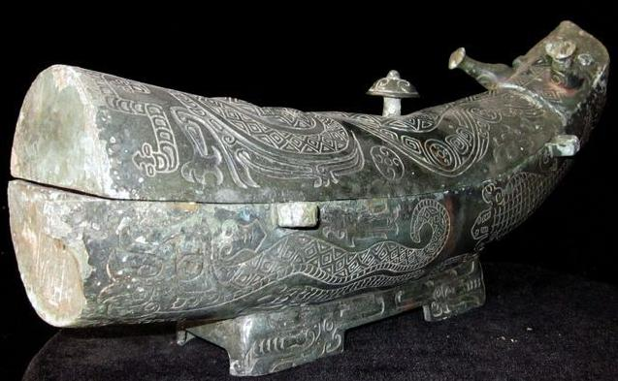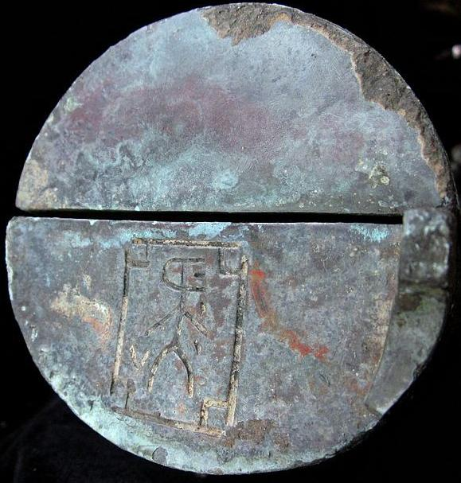

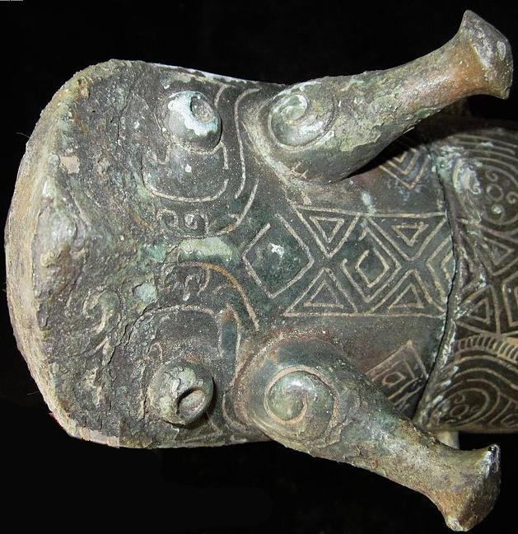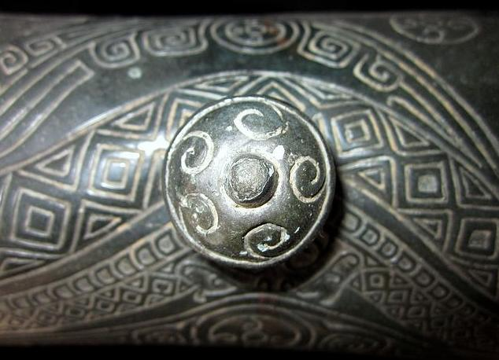

Water wave carvings on knob with diamond reptilian skin pattern of snakes on lid.

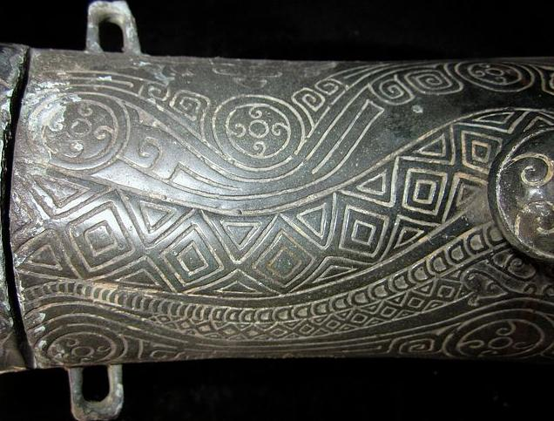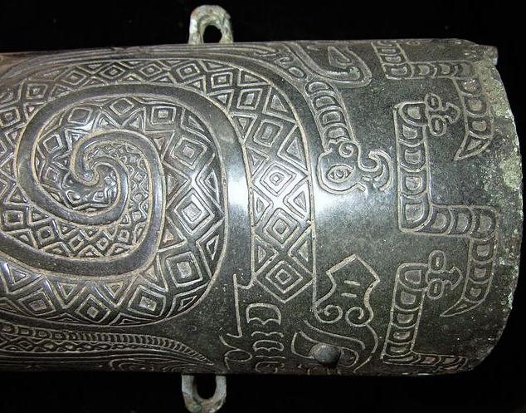

4Rings on the body, which was used for connecting the rope and body..

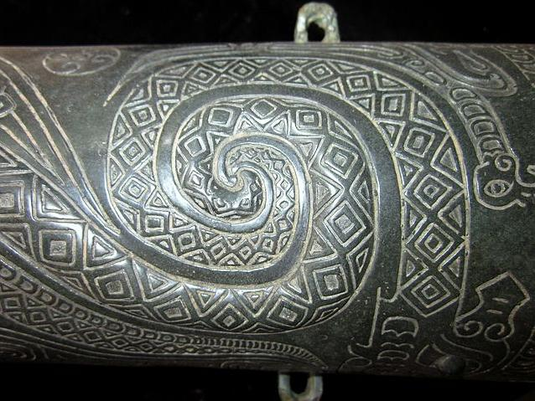

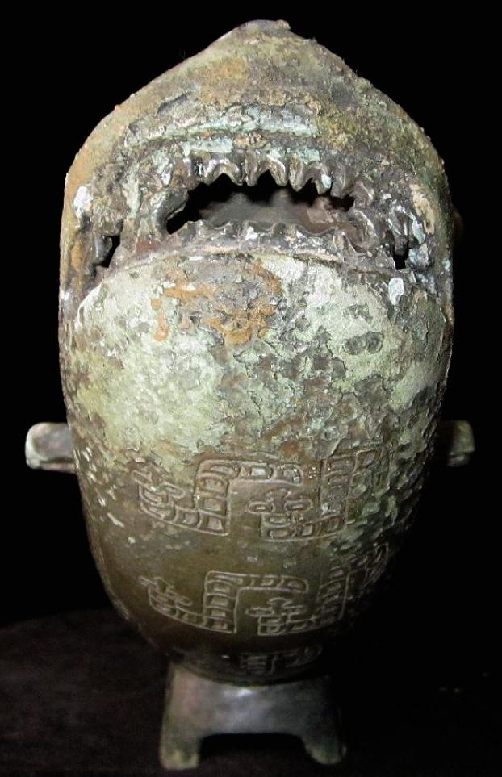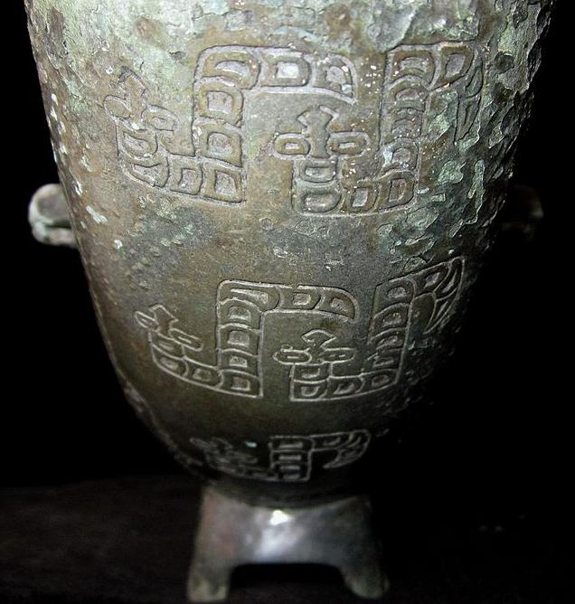 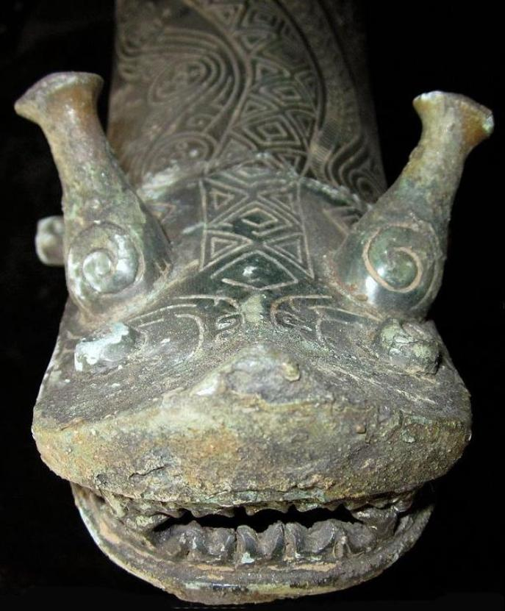

View of snout and composite antler-horns: bottle-shaped muntjak deer antlers with curved argali horns carved on them.

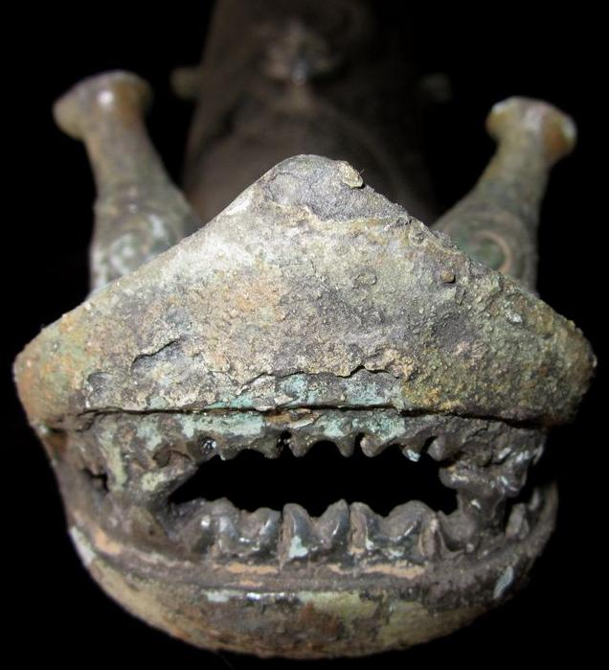

Shark-like snout with shark-like teeth.

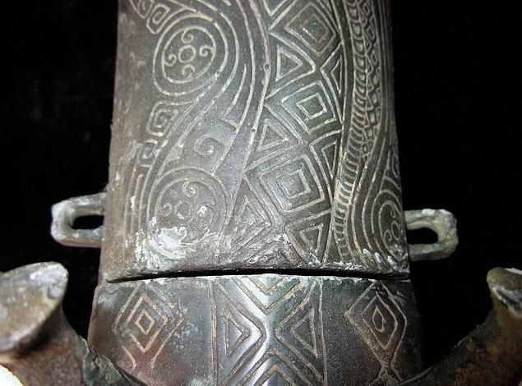

Composite curvilinear water motifs within circles and diamond patterned snake skin on dorsal ridge.

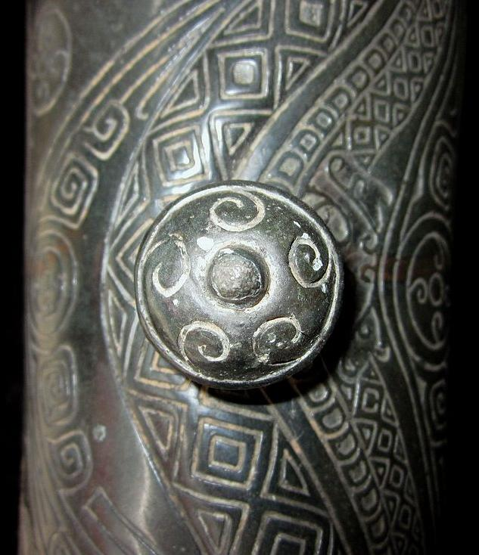

Water wave carvings on knob with diamond snake-skin pattern on lid.

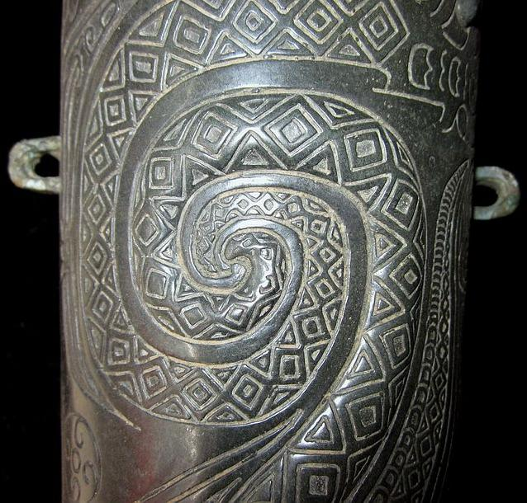 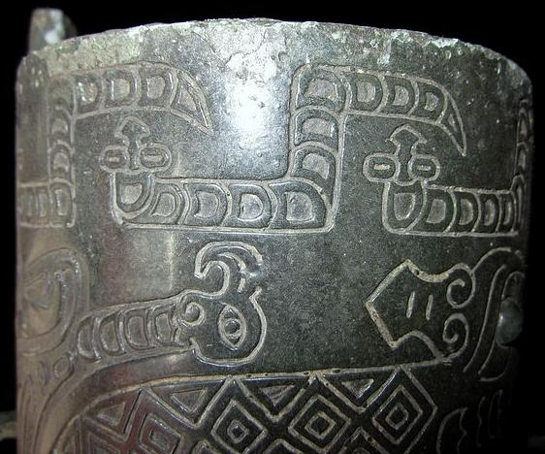 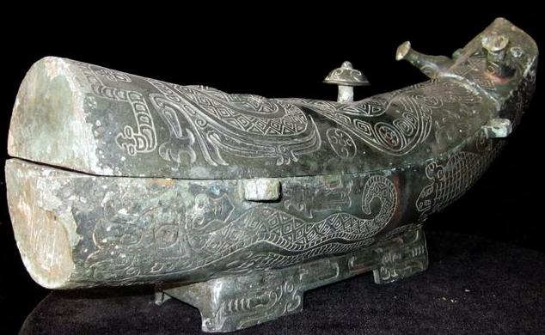 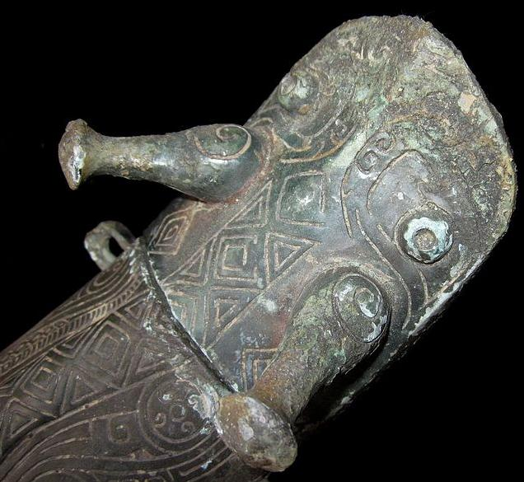 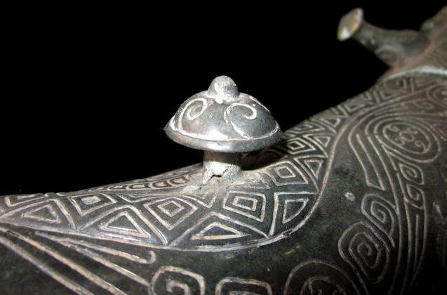 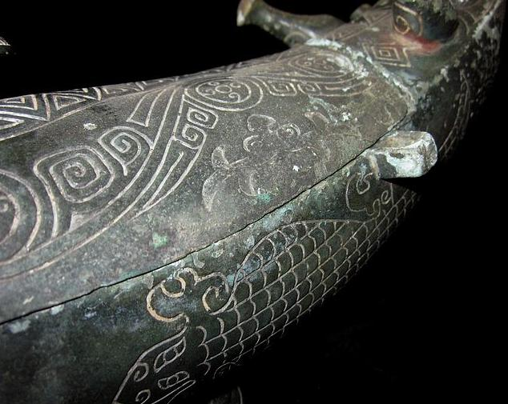 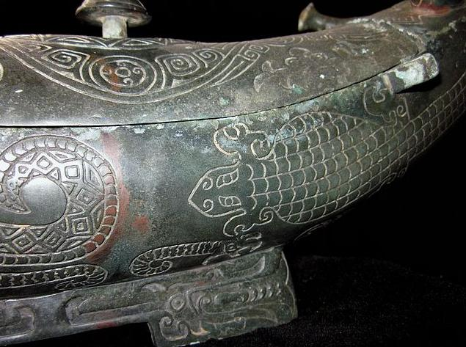 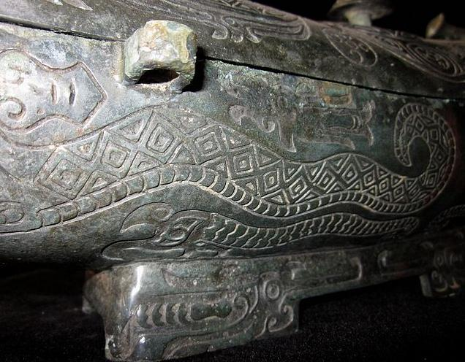 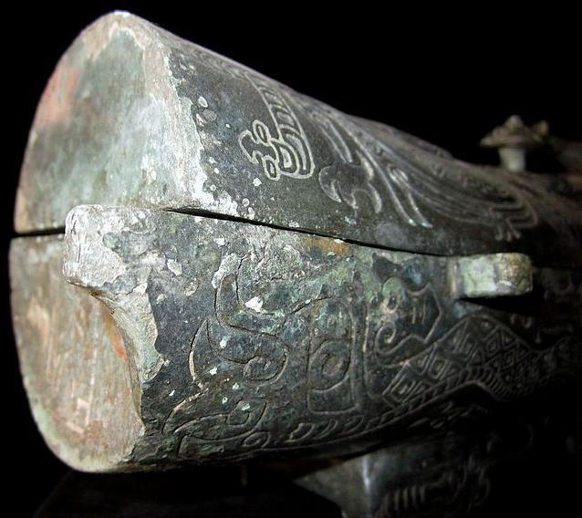 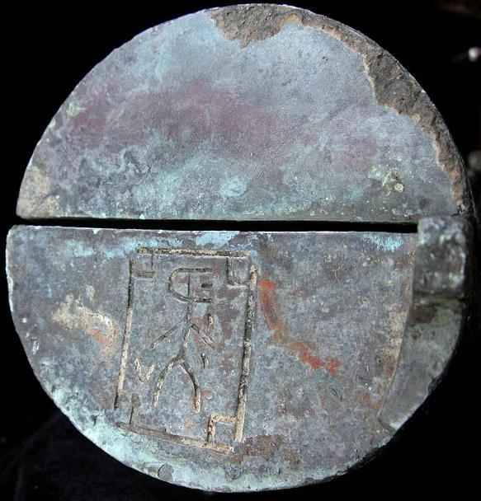

Sealing words on the body.

China-Shang-Guang-Alligator with Muntjak Deer Horns- Shilou County, Lüliang, Shanxi-Bronze-1600-1046 BCE

Case No.: 5

**Accession No.**

**Formal Label:**

China-Shang-Guang-Alligator with Muntjak Deer Horns- Shilou County, Lüliang, Shanxi-Bronze-1600-1046 BCE

**Display Description:**

Bronze Wine Ware Pot Guang Dragon Motifs on the body, very rare.

**LC Classification: DS 744**

**Date or Time Horizon:**

**Geographical Area:**

Map:

**GPS coordinates:**

**Cultural Affiliation:**

**Medium: bronze**

**Dimensions:**

LENGTH:38CM/14.96Inches

HEIGHT:17CM/6.69Inches

**Weight:**

**Condition:**

**Provenance:**

**Discussion:**

**References:**